Bios

Here are examples of bios that I am using for Twitter, for the Data Action Lab blog, and for formal proposals
____________________________

Twitter Bio
Objective: to have a presence on the Twitter platform.

Twitter  @idlewyld_IACS | 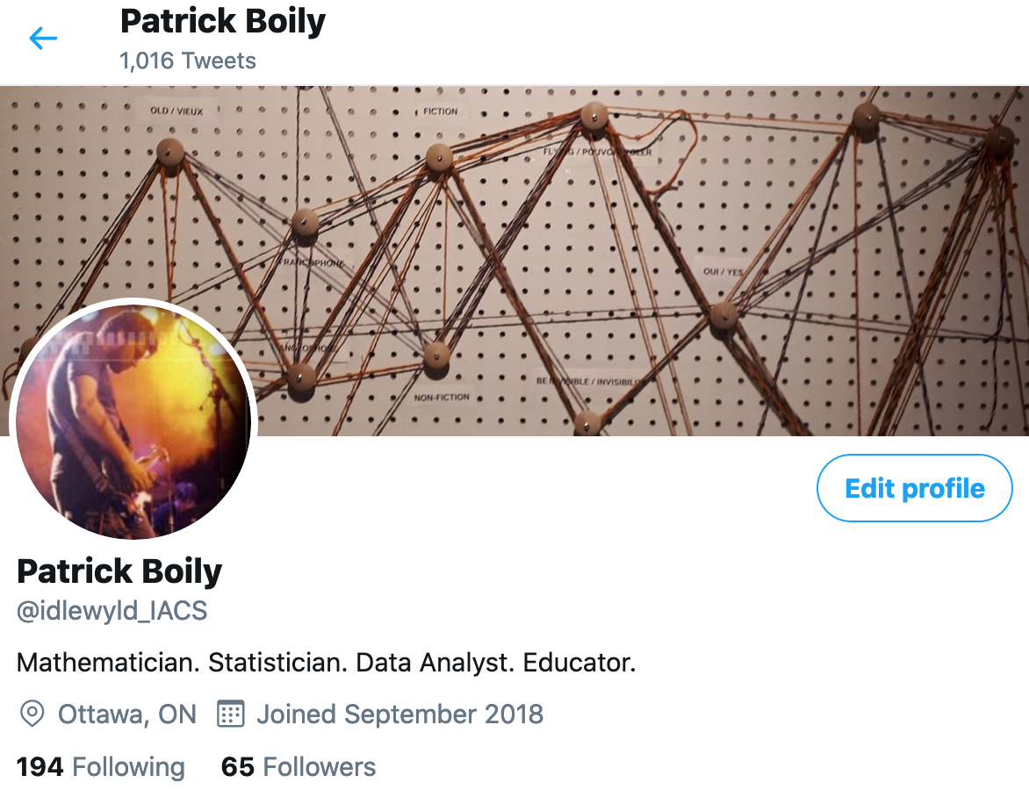

Not exactly influencer material, I’ll admit.
____________________________

Online Persona
Objectives: I have been told that too many credentials can sometimes be intimidating for potential clients. I’m of two minds about this. One the one hand, we should not have to “dumb ourselves” down to appeal to clients; on the other hand, a profile that is overly academic and/or serious might make us appear distant and unavailable in the eyes of clients. If the goal is to try to appeal to a more general audience (typically the case in an online situation), something like the following might be appropriate:

Data Action Lab |   As a child, Patrick used to read everything he could lay his hands on. For years, he believed that the NHL would have come calling if he hadn’t broken his leg in a hilarious-in-hindsight skiing mishap. Nowadays, whatever’s left of his hair is slowly turning grey, and that can only mean one thing: he’s had the opportunity to work on quantitative projects aplenty, providing expertise to various clients in the fields of operations research, data science/machine learning/predictive analytics/artificial intelligence, stochastic and statistical modeling, and simulations. He’s not overly keen on buzzwords, but he’s glad to see interest in analytical endeavours grow. He thinks that insights and discoveries are within everyone’s reach (and for the record, he would have been a great goalie).

With this text, I was trying to seem non-threatening (but it stills feels a bit stilted and forced to me...). Among a certain segment of potential clients, self-deprecation does not work the way one might hope (there’s a definite element of humblebrag at play, I think).
____________________________

Short Formal Bio
Objectives: basically, the short formal bio summarizes the CV in a few paragraphs. Let your professional accomplishments shine through – this is your time to “brag”. As the bio is short, the bragging is contained, but make sure you tone it way down in the rest of the document.

Patrick Boily, Ph.D. | Patrick is a graduate from the University of Ottawa. He obtained his Ph.D. in Mathematics in 2006. He has taught over 40 courses at Universities in the Ottawa area since 1999, and worked on a number of projects as a federal public servant from 2008 to 2012 (including the award-winning Canadian Vehicle Use Study).  He started and managed Carleton University’s Centre for Quantitative Analysis and Decision Support from 2012 to 2019. He is now a professor in the University of Ottawa’s Department of Mathematics and Statistics. His academic interests reside in the application of mathematics and statistics to evidence-based decision support.  He has provided consulting services to numerous entities over the years, including United Way, the Public Health Agency of Canada, the Canadian Air Transport Security Authority, the Royal Canadian Mounted Police, Transport Canada, the Nuclear Waste Management Organization, the Privy Council Office, and Correctional Services Canada.  He has extensive experience in operations research, data science and predictive analytics, stochastic modeling, and simulations – managing and being involved in numerous projects in these subject areas from inception to completion. He also leads various workshops on data science and statistical analysis.

I only ever point out my degree in two instances: on a business card (because I’ve noticed that clients expect to see it there), and on title pages (presentations, reports, etc.) I never refer to myself as a Ph.D., and typically ask people to just call me Patrick. Insisting on a honorific title is one of the surest way to get disqualified from getting a contract when there are more than one successful bidder. I believe that clients are looking for people they can work with, both on the technical side of things and on the personal side.

